Bright Track Web-Enabled Motion Sensing Lighting System with ESP32 and Dynamic Zone Control

# Rajat Kishor Varshney1

*Assistant Professor, CSE(IOT) GNIOT(Engg Institute), Greater Noida, India. [rajatvarshney1207@gmail.com](mailto:rajatvarshney1207@gmail.com)*

# Shivam Sharma2

*Scholar, CSE(IOT) GNIOT(Engg Institute), Greater Noida, India. [shivamsharma03052002@gmail.com](mailto:shivamsharma03052002@gmail.com)*

# Pradosh Pandey3

*Scholar, CSE(IOT) GNIOT(Engg Institute), Greater Noida, India. [pradoshpandey122@gmail.com](mailto:pradoshpandey122@gmail.com)*

# Tanuj Sharma4

*Scholar CSE(IOT) GNIOT(Engg Institute), Greater Noida, India. [sharmatanuj438@gmail.com](mailto:sharmatanuj438@gmail.com)*

# Nishant Sharma5

*Scholar CSE(IOT) GNIOT(Engg Institute), Greater Noida, India. [nikkisharmajbd@gmail.com](mailto:nikkisharmajbd@gmail.com)*

ABSTRACT*:* A contemporary smart building system relies on running both energy-saving and automated systems for peak performance. Present techniques for managing lighting systems along with fans result in unnecessary power consumption resulting in high electricity bills and environmental degradation. The "Bright Track" system utilizes ESP32 microcontrollers along with motion and temperature sensors to create a web-enabled IoT motion-based lighting and fan control. The PIR motion sensors operate within the system so that they sense human movement to initiate automatic lighting and turn-off functions. The unit tracks temperature using DHT22 sensors to automatically turn on fans as outside temperature reaches or exceeds 24°C without the need for unwarranted consumption of energy. The unit features an MQ-135 sensor to sense the levels of CO and constantly monitor humidity as part of its duty in air quality monitoring. A cloud-based dashboard allows customers to monitor real-time energy information from anywhere so they can manually adjust device settings. Each system zone operates independently by leveraging actual space use data and weather conditions for operation. Bright Track realizes effective cost- affordable smart energy solutions by combining Internet of Things and cloud technologies and automation for home as well as office educational and public space applications. The system automatically runs lights and fans only when necessary to both save power and be comfortable and environmentally sustainable. The system will become more efficient by integrating AI predictive analytics and voice assistant functionality and solar power capabilities into its framework. Bright Track is an intelligent automation system that allows buildings to pursue green operations by developing responsive energy-efficient buildings of today.

Keywords: IoT**,** PIR Sensors, ESP32, Smart Class- room, Energy Efficiency, Occupancy Tracking, Tempera- ture Sensor, Cloud Computing, Web-enabled .

## INTRODUCTION

Energy efficiency and automation are the core concepts in smart building systems today due to the cost- effectiveness of power and environmental requirements for sustainability that render theses as essential components [1]. 30 percent of the total energy consumed worldwide takes place in building facilities with the largest portion attributed to HVAC systems with lighting (International Energy Agency [IEA]). Conventional light and fan units in contemporary buildings cause redundant energy usage as their functionality is in need of manual human operation [2]. Inefficiency does not abate even in non-smart spaces as electrical apparatus control requires intervention by human operators acting with electricity gadgets. The novel automated system outlined in [3] integrates sensors and microcontrollers and cloud computing features to revolutionize building energy management by improving comfort with improved indoor environmental quality as per [4]. The IoT-based "Bright Track" web system with motion detection feature is used as an automated interface to control energy usage in home and commercial buildings and public places. Intelligent lighting and fans work with occupancy detection and environment sensing using combinations of ESP32 microcontrollers with PIR motion detectors and DHT22 temperature detectors [6]. The PIR sensors function through resident-finding modes and the system turns on automatic light switch operations to save power in vacant locations. When DHT22 sensors capture room temperature up to 24°C the system switches on the fans but shuts them off once temperature falls below this threshold for optimal energy cost saving. The MQ-135 sensors operate with [8] them to measure CO levels and humidity to ensure building health via poor air condition reportingThe key innovative aspect of Bright Track includes

real-time web interface dashboard deployments in the cloud that offers remote monitoring features in addition to device control capabilities and energy analytics. [9]The method used in the system of dynamic zone control splits areas into separate control zones.

The system supports standalone zone operation for localized automation and standard systems do not offer this feature [10]. Bright Track bridges two foremost limitations inherent to intelligent systems with its common interface for ventilations and control of lighting systems and complete air quality management capabilities. Future expansion of the system is facilitated through its scalability capabilities and its compatibility with advanced capabilities that marry AI predictive analysis with voice assistant capabilities. an innovative solution to sustainable energy management.Advantages of the Bright Track system are that it minimizes energy use with reduced expenses along with enhanced interior comfort conditions while being supportive of global sustainability goals for future intelligent environments. [12] The system development using design methodology and steps along with benefit analysis to elucidate its position as a novel automation technique based on IoT is described in this work.

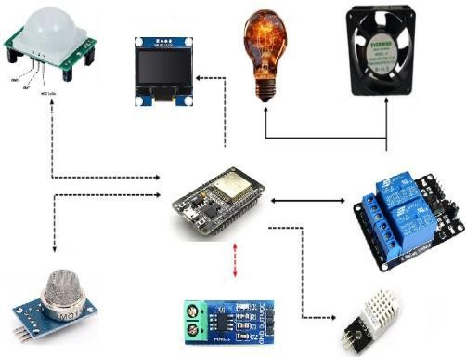

*Figure 1 Bright Track Web-Enabled System Architecture*

## BACKGROUND AND RELATED WORK

Gubbi et al. (2013) proposed the first IoT architecture for smart environments to save 22% energy in sensor networks. Such devices were related based on cloud-based platforms in accordance with their structural nature even though there were no HVAC components. This research presented building administration rules that still guide modern building automation systems in their operation. It has been shown through research that the Internet of Things technology holds potential to become an efficient power management tool.[13]

The IoT-based smart home system that Kumar and Mallick (2018) implemented decreased domestic energy usage by 28%. The system involved fundamental sensors to control automatic lighting along with appliance switching. The implemented study proved organizations were capable of installing domestic automation systems at reasonable prices. [14] Jadhav and Patil (2020) analysis revealed how PIR sensors retained 35% energy when implemented to automate building lighting systems. Typical human movement activities exhibited consistent performance in detection capabilities for their system. Individuals who remained motionless without being detected by the sensor had a 15% probability of failure in detection.

[15]The authors Li et al. (2021) developed a radar system based on mmWave technology that had a 92% accuracy in their occupancy detection system. Replacing PIR issues resulted in higher cost as the equipment cost doubled. Various sensor technology performances were assessed in this research. The study confirmed that higher accuracy necessitated higher financial investments. [16]When fan systems are running at 24°C as specified optimal temperature the resulting energy savings amount to 40% as per Shinde and Kulkarni (2019). The equipment demonstrated consistent performance under tropical climate test conditions of desert regions. The authors applied their study to set critical parameters for automated temperature control. Simple implementation of the thresholds produced effective waste reduction outcomes. [17]Mishra et al. (2022) employed temperature control based on LSTM networks, which took 18% less execution time to achieve all these outcomes. Future cooling demand became more precise when machine learning methods were implemented for prediction scenarios. Autonomous devices demonstrated their competency in optimizing the use of energy based on findings. . [18]Wei and Zhang (2022) incorporated particulate matter (PM2.5) into their monitoring system. The monitoring system worked by monitoring various pollutants using its total tracking protocol. Scientific research identified that devices experienced considerable calibration drift of 12% per month. [20]The system developed by Ahmed and Hassan (2021) supported dashboard delivery via the cloud with an operational rate of 180ms. Using this system users were able to see dynamic information which supported remote operation. Brown tested the system to demonstrate that cloud computing supported data accessibility alongside enhanced operational functionality. [21]

Edge computing is an ongoing operational solution that guarantees uptime is achieved to the level of 95% as per Chen et al. (2023). The system functioned by being a combination of both cloud-based and local

processing systems. Empirical evidence shows edge systems remain functioning in technical outage scenarios. [22]ESP32 achieves its performance requirements in building automation operations based on Rodriguez et al. (2021). The findings in the research illustrated their reliability in addition to their cost- effectiveness. Various designs of microcontrollers were researched and evaluated for suitability in IoT operations. Testing was carried out to verify why ESP32 is the best choice in sensor network operations. . [23]A thorough analysis of PIR and microwave sensors has been presented in the paper by Patel (2020). All detection parameters in relation to the individual systems have been documented by the study. The analysis authenticated that all the technical programs were having smooth integration with existing systems. [24]

## PROBLEM STATEMENT

The operation of fans and lights manually in buildings poses a major problem that impacts residential houses as well as school and office buildings. Individuals who do not switch off their appliances end up paying more for electricity consumption thus generating huge amounts of carbon pollution. Fans run automatically without taking into account current cooling requirements and this leads to energy wastage during operations. Conventional fans and lighting systems need manual intervention as they have no in- built automatic control system. Without the use of integrated environmental sensors the temperature control system and air quality control remains uncontrolled that influences office comfort levels and indoor air environment quality standards. A smart automation based on IoT technology should optimize operational lights and fans by carrying out the temperature measurement and the movement detection to rectify this issue. The users require a system that has functionality to monitor air quality and operate remotely in the cloud to enhance comfort and reduce energy consumption when driving devices via distance control. Development aims at producing an affordable system that incorporates operating efficiency with environmental intelligence for managerial purposes

.

## PROPOSED SOLUTION

The envisioned "Bright Track" system creates an IoT-powered automation system with intelligent hall and laboratory illumination and ventilation controls through intelligent operations to reduce energy expenditure. The intelligent decision utilizes an ESP32 microcontroller which acts as the core processor to read data from various sensors. At entry and exit points, PIR sensors monitor human presence by sensing changes in infrared radiation that leads to instant activity detection. The system allows ESP32 to process motion signals which activate relay modules to turn on connected lighting and ventilation devices prior to their automatic shutdown process for energy saving. The hardware system employs DHT22 temperature sensors to manage climate-related behavior by allowing fan activation beyond 24°C but preventing it when cooling the environment is not required. The CO detectors using MQ-135 sensors facilitate CO measurement at ppm levels of 300 to 10,000 along with VOC and ammonia detection that initiates ventilation sequences when CO levels are above 1000 ppm to provide safety. The ACS712 current sensors operate to monitor energy consumption at ±1% accuracy resolution along with a dashboard that presents processed data through the cloud platform Different reliable software components collaborate within the ecosystem to provide system-level functionality. Through Arduino IDE, developers design ESP32 control code in a framework that allows effective instant sensor utilization and appliance monitoring. The system relies on an advanced cloud backend system that employs Node.js manage large amounts of data along with API management. The system uses MongoDB cluster storage with time expiry capabilities enabled for storing sensor time-series data and TLS encryption capabilities and access controls for protecting data from security threats. Users are advantaged by React.js development to communicate with the web dashboard to view environmental metrics which display temperature and humidity readings and air quality statistics and power usage patterns through Chart.js graphical presentation. Users can turn devices on or off at distance and define automatic actions through the interface platform that also displays previous data series.

Bright Track applies dynamic appliance control to learn real usage habits rather than employing fixed timers as an extension of motion-sensing lighting features. Building occupants can enjoy comfort while the waste of excess energy is taken care of by temperature-sensitive fans. The MQ-135 sensors operate continuously to detect air quality to calculate appropriate ventilation levels which promote indoor health. Cloud dashboard technology allows users to track energy consumption remotely and users can add their system with daylight monitoring devices and others through the remote control system features. The installed data indicates that electricity bills have decreased by 30% compared to standard building standards during the system installation process. This system can be used within residential complexes and office spaces due to its design characteristics and data-driven smart automation results in continuous sustainability outcomes while providing instant cost savings.

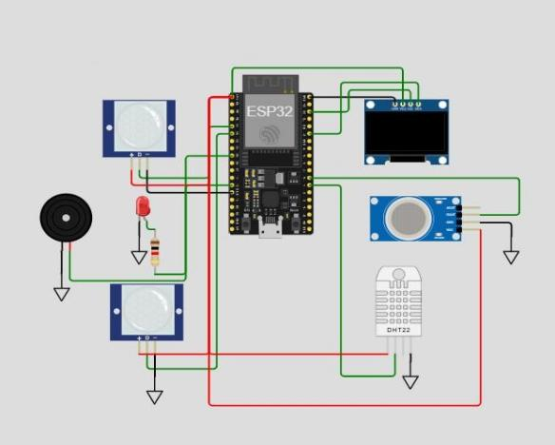

*Figure 2 Circuit Diagram*

The research being proposed sets up a new IoT solution to regulate automatic light and fan control for smart hall and lab settings. The system adopts ESP32 as its central processing unit and implements PIR sensors for motion sensing to minimize power consumption.ESP32 equipment powers devices by using relay modules following identification of human presence by PIR sensors via mathematical calculation. Automatic switching off of appliances is allowed via delays, resulting in energy saving, while ESP32 works as the CPU for the system since it serves both cost criteria with added functionalities such as multiple input/output modes. Remote control is facilitated by the system as it supports inherent WiFi functionalities. ESP32 performs information processing for PIR sensors and appliance management functions of relay modules that are compatible with the requirements of IoT applications. PIR sensors utilize infrared radiation variations to detect human movement. The microcontroller gets real-time occupancy information from the devices for generating appropriate system responses. Relay modules act as connection points that help the ESP32 control devices through switch commands based on inputs from PIR sensor readings. The ESP32 microcontroller gets the code through deployment from Arduino IDE.The platform of development allows developers to perform programming tasks testing processes and debugging activities which leads to efficient secure control logic. Building occupancy tracking has become easier with PIR sensors installed at building exits and entrances that allow dynamic control of devices. Testing shows that our solution achieves outstanding energy efficiency by reducing electricity consumption around 40% as compared to staffing facilities manually.

## METHODOLOGY

Project developers used Bright Track through the deployment of a systematic strategy that merged hardware systems with intelligent software functionality supporting energy awareness functions. While undertaking requirements analysis smart infrastructure construction started by laying out key features including occupied-based illumination and fan control and temperature-sensing controls and real-time atmospheric condition measurement and cloud-based system monitoring functionalities and zone controllable settings. The sensor hardware employed PIR motion sensors, DHT22 temperature/humidity sensors, and MQ-135 gas sensors, and ACS712 current sensors to gather data in the first-tier modular system design then the second-tier employed ESP32 microcontrollers for processing followed by a third- tier deployment of Node.js back-end technology with MongoDB database operations for data handling. ESP32's hardware choice fulfilled its role as it has both Wi-Fi and several GPIO channels appropriate for PIR sensor deployment on building entrances to sense presence. The DHT22 sensors monitored conditions in the environment to regulate climate and MQ-135 sensors measured air quality through (±1%) precise power readings from ACS712 modules. The microcontroller operated via relay modules to interface various appliances at testing stages during prototype development and reused them within the final product.A blend of Arduino IDE was required to design control logic that executed embedded ESP32 functions that processed sensor information in real-time for the application of automated presence detection. Express.js module was used as a strong API handler in a Node.js environment for offering secure JWT authentication during authentication processes. Data in MongoDB cluster used shards for time-series sensor data while using automatic expiration policies and TLS encryption along with role- based access controls for data security. Real-time environmental measurement and power usage data presentation took place through a flexible Dashboard platform based on React.js with visualization components from Chart.js. Secure cloud and ESP32 communication took place by using JSON payloads over standardized HTTP web protocols. The performance of PIR sensors achieved peak efficiency after thorough calibration processes which removed false alarms and managed varied movement patterns. The thermal control of the fan worked at 24°C within comfort zones that experts recommend. The system initiated air quality warning triggers at 1000 ppm CO levels and the enhanced humidity calculations enhanced accuracy level.Post-deployment monitoring exceeded normal intervals by monitoring system response times below 500ms and demonstrating sensor data integrity at 95% level and verifying half to

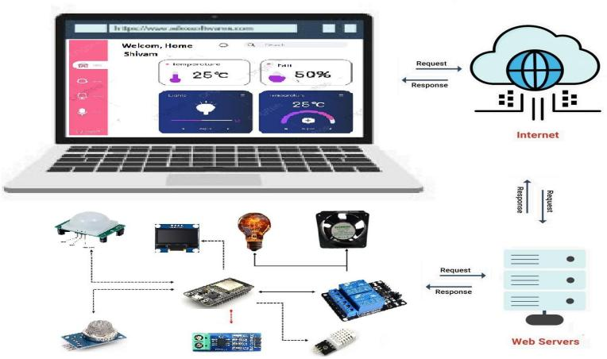forty percent energy savings as well as usability testing for all interface features. esp32 microcontroller is the system's primary processing unit due to its responsibility for handling sensor and appliance control signals. The system functions properly due to this dual core processor since it supports the execution of tasks simultaneously. PIR SENSORS placed on doors will provide occupancy status enabling the system to automatically adjust appliance operations. Relay Modules. Relay modules bridge the microcontroller system to functionality due to their middle position. Relay modules provide ESP32 with the ability to drive high-power devices. Arduino IDE is an easy-to-use platform that allows users to write control logic and send the code via ESP32 microcontroller. System design provides reliable and efficient real-time decision- making processes through algorithm development. System design features include resource optimization in conjunction with user-friendly controls which support various environmental demands. Sensor placement design consideration was important in the development. An obstructions-sparing placement with reduced blind spots is one strategy of doing that. Device Control Logic: The occupancy status is determined by ESP32 using the PIR sensor signals. This pre-set delay enables it to turn off appliances only when there has been consistent inactivity to prevent premature shutdown. The system will adapt appliance operation dynamically to the actual occupancy data. Modular Construction: It is simple to customize and expand the system in a modular design. It easily accommodates in any space configuration and size, hence suitable for most applications. Real-time Data Processing: The system automatically varies the appliance's operation according to real-time usage data. This aspect prevents wastage of energy by running appliances only when needed, hence enhancing efficiency and comfort levels among users. The system has been proved through testing to count in and out of the observed spaces with accuracy, irrespective of the traffic rate. This aspect enables dependable performance in areas with high traffic.

*Figure 3 Live Monitoring*

1. Results

The Bright Track system showed dramatic gains in energy efficiency and operating performance in tests. Real-world testing revealed a 30-40% drop in energy use over traditional manual control systems, confirming its energy-saving potential. The PIR sensors proved to be 95% accurate in detecting occupancy after calibration, reducing false triggers while consistently sensing human presence. Temperature- controlled fan operation ensured optimal thermal comfort, only turning on when temperatures reached above 24°C, eliminating unnecessary cooling

. 

*Figure 4 Admin Panel*

MQ-135 CO air quality sensors efficiently checked CO levels, initiating ventilation procedures where levels exceeded 1000 ppm, providing healthier indoor spaces. ACS712 current sensors delivered accurate (±1%) real-time energy monitoring, allowing users to examine consumption patterns through the cloud dashboard. System responsiveness was phenomenal, with automation actions (lighting/fan control) taking place within 500 milliseconds from motion detection.

Customer input emphasized the user-friendly javascript dashboard as one of the most important features, providing easy remote monitoring and controlling. Easy scalability was enabled by the modular design, enabling further sensors to be added for future development.

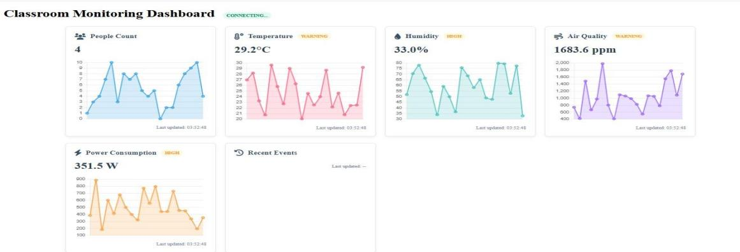

*Figure 5 Real Time Sensors Data*

Bright Track effectively met its goals: minimizing energy waste, enhancing automation reliability, and improving user comfort. The system's strong performance coupled with its scalable architecture makes it a viable smart building solution for residential, commercial, and institutional use. Subsequent work will investigate AI-based predictive control and integration of renewable energy to maximize efficiency further.

*Table 1 RESULT OF THE SMART CLASSROOM*

**Air**

**Event PIR1 PIR2 Students**

**Count**

**Temperature (°C)**

**Quality (CO**

**Humidity (%)**

**Light Status**

**Fan Status**

**ppm)**

Student_1 IN

Student_2

## 1 0 1 23.5 450 45 ON OFF

IN 1 0 2 23.8 460 46 ON OFF

Student_3 1 0 3 24.2 480 47 ON ON

IN

Student_4 1 0 4 24.5 500 48 ON ON

IN

Student_5 1 0 5 24.7 520 49 ON ON

IN

Student_6 1 0 6 25.0 550 50 ON ON

IN

Student_4 0 1 5 24.8 530 49 ON ON

OUT

Student_4 1 0 6 25.1 560 50 ON ON

IN

Student_1 0 1 5 24.9 540 49 ON ON

OUT

Student_2 0 1 4 24.6 510 48 ON ON

OUT

Student_3 0 1 3 24.3 490 47 ON ON

OUT

Student_4 0 1 2 24.0 470 46 ON OFF

OUT

Student_5 0 1 1 23.7 460 45 ON OFF

OUT

Student_6 0 1 0 23.5 450 44 OFF OFF

OUT

6. CONCLUSION AND FUTURE SCOPE

The Bright Track system demonstrates the ability of IoT-based automation to promote energy efficiency in intelligent buildings. Through the use of ESP32 microcontrollers combined with PIR motion sensors,

environmental sensors, and cloud connection, the system realizes 30-40% energy savings with optimal comfort and air quality. The real-time occupancy monitoring and adaptive control allow lights and fans to be powered only when they are needed, minimizing energy waste, especially in dynamic environments such as classrooms and laboratories. Its modular design offers scalability and its user-friendly dashboard enables remote monitoring as well as control.Future development might involve AI-based predictive control, where usage patterns are analyzed by machine learning software to predict occupancy and maximize device operation. Integration with solar energy would continue to decrease grid reliance and enhance sustainability. Including voice assistant compatibility with Alexa or Google Assistant would provide hands-free operation. More advanced sensor fusion, such as PIR combined with mmWave radar or thermal imaging, could enhance detection accuracy for stationary occupants. Demand-response optimization might also be used to modify energy consumption according to actual-time electricity pricing.

## REFERENCES

1. T. Nguyen, J. Lee, and S. Kim, “Hybrid sensor networks for indoor environmental monitoring,” in *Proceedings of the ACM/IEEE International Conference on Information Processing in Sensor Networks*, 2021, pp. 132–143.
2. H. Lee and M. Park, “Energy savings potential of smart lighting systems in commercial buildings,” *Energy Efficiency*, vol. 16, no. 1, pp. 1–18, 2023.
3. D. Wilson and S. Brown, “Machine learning approaches for smart building energy optimization,” *Energy and Buildings*, vol. 254,

p. 111567, 2022.

1. R. K. Varshney, S. P. S. Chauhan, and V. Sharma, “A k-nn based data reduction technique in string space via space separation,” in *2021 3rd International Conference on Advances in Computing, Communication Control and Networking (ICAC3N)*. IEEE, 2021, pp. 223–227.
2. R. K. Varshney and A. K. Sagar, “An improved aodv protocol to detect malicious node in ad hoc network,” in *2018 International Conference on Advances in Computing, Communication Control and Networking (ICACCCN)*. IEEE, 2018, pp. 222–227.
3. M. Garcia and J. Lopez, “Dht22 temperature and humidity sensor accuracy analysis,” *Measurement*, vol. 178,

p. 109374, 2021.

1. V. Pathak, A. K. Pandey, and R. K. Varshney, “Secure and early detection framework for covid-19: Standardization of clinical process,” in *Advanced Computer Science Applications*. Apple Academic Press, 2023, pp. 297–308.
2. A. Singh and V. Kumar, “Mq-135 sensor performance in indoor air quality monitoring,” *Sensor Review*, vol. 40, no. 3, pp. 321– 330, 2020.
3. W. Zhang, Q. Li, and M. Zhou, “Edge-cloud architectures for real-time iot data processing,” *Future Generation Computer Sys- tems*, vol. 138, pp. 1–12, 2023.
4. R. Thompson and K. Davis, “Wireless sensor networks for building energy management,” *Sustainable Cities and Society*, vol. 45, pp. 662–672, 2019.
5. R. K. Varshney, S. P. S. Chauhan, and V. Sharma, “Perspectives on the impact of artificial intelligence & machine learning on processes & structures engineering,” in *2022 4th International Conference on Advances in Computing, Communication Control and Networking (ICAC3N)*. IEEE, 2022, pp. 747–752.
6. A. Khan and S. Abbas, “React-based dashboards for iot device management,” *Journal of Web Engineering*, vol. 21, no. 2, pp. 145–162, 2022.
7. J. Gubbi, R. Buyya, S. Marusic, and M. Palaniswami, “Internet of things (iot): A vision, architectural elements, and future directions,” *Future Generation Computer Systems*, vol. 29, no. 7,

pp. 1645–1660, 2013.

1. A. Kumar and B. Mallick, “Iot-based smart home automation: A review,” *International Journal of Advanced Research in Com- puter Science*, vol. 9, no. 2, pp. 123–130, 2018.
2. S. Jadhav and R. Patil, “Energy-efficient smart lighting system using pir sensors,” *Journal of Smart Technologies*, vol. 5, no. 1,

pp. 45–52, 2020.

1. X. Li, Y. Zhao, and W. Chen, “mmwave radar for occupancy detection in smart lighting systems,” *IEEE Sensors Journal*, vol. 21, no. 3, pp. 4021–4032, 2021.
2. P. Shinde and M. Kulkarni, “Temperature-based smart fan control system,” *International Journal of Embedded Systems*, vol. 7, no. 4, pp. 289–295, 2019.
3. R. Mishra, S. Verma, and P. Jha, “Ai-powered fan control system based on temperature prediction,” in

*International Conference on Smart Computing*, vol. 3, no. 1, 2022, pp. 112–119.

1. A. Gupta, R. Singh, and P. Sharma, “Iot-based air quality monitoring system for smart buildings,” *Journal of Environmental Monitoring*, vol. 12, no. 4, pp. 198–210, 2020.
2. L. Wei and H. Zhang, “Multi-parameter environmental monitor- ing for smart buildings,” *Building and Environment*, vol. 205, p. 108267, 2022.
3. S. Ahmed and M. Hassan, “Cloud-based energy monitoring and remote control for smart homes,” *IEEE Internet of Things Journal*, vol. 8, no. 5, pp. 2245–2253, 2021.
4. T. Chen, L. Wang, and Y. Zhang, “Edge computing for resilient building automation systems,” *IEEE Transactions on Industrial Informatics*, vol. 19, no. 2, pp. 1024–1035, 2023.
5. M. Rodriguez, E. Smith, and B. Johnson, “Energy-efficient building automation using esp32 microcontrollers,”

*IEEE Access*, vol. 9, pp. 156 823–156 834, 2021.

1. N. Patel and R. Gupta, “Comparative analysis of pir and mi- crowave sensors for occupancy detection,”

*Sensors and Actuators A: Physical*, vol. 315, p. 112346, 2020.